Old Colony & Newport Railway

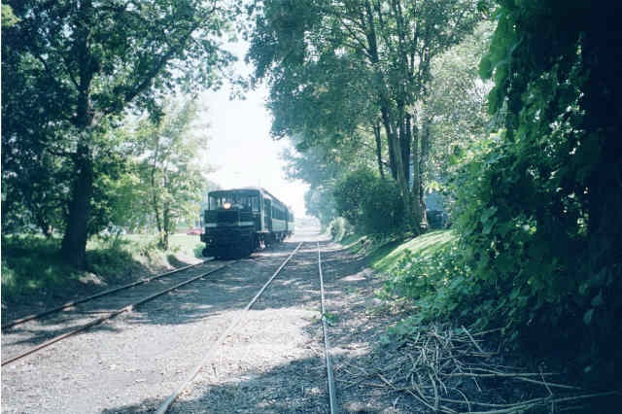

Summary of Information
2002

Table of Contents
Our Mission Statement 3
Schedule 3
The Ride 3
The History of the Newport Line 5
Membership 9
Supporting Members 9
Working Members 9
The Newport Dinner Train 10
Photo Gallery 10
Credits 14
Contact Information 15
Telephone: 15
Mail: 15
Email: 15
Web site: 15

Table of Figures
Figure 1 Newport Depot 3
Figure 2 Battleship Iowa 3
Figure 3 Heading North 3
Figure 4 The Coach 4
Figure 5 The Parlor Car 4
Figure 6 The Parlor Car & Stove 5
Figure 7 Green Lane 5
Figure 8 Old Colony Map 6
Figure 9 Fall River Line Poster 7
Figure 10 Newport Wharf Depot 7
Figure 11 Gate 4 Overpass 8
Figure 12 Excursion 8
Figure 13 Volunteers Enjoying a Weekend 9
Figure 14 Volunteers Moving the Track Car Shed 9
Figure 15 At the Newport Depot 10
Figure 16 Heading South at Lawton's Valley 10
Figure 17 Heading North at McAllister's Point 11
Figure 18 Mile Post 11
Figure 19 Disembarking at the Station 11
Figure 20 Leaving Newport on a Snowy Day 11
Figure 21 Old Colony Passing Stacy House 12
Figure 22 Battleship Iowa 12
Figure 23 Coupling in the Snow 12
Figure 24 Track at Gate 4 12
Figure 25 Caboose in the Snow 13
Figure 26 Coaches on a Snowy Day 13
Figure 27 Burma Road 13
Figure 28 Better Weather is Coming 13
Figure 29 Downtown Newport Tracks 13
Figure 30 Track Cars Come to Town 14
Figure 31 Heading to Melville with the Shed 14

Our Mission Statement
The National Railway Foundation and Museum, located in Newport RI and operator of the Old Colony & Newport Railway, is a 501 (c) (3) non-profit educational organization dedicated to the preservation, restoration and operation of historic railway equipment, and the preservation of Narragansett Bay and the surrounding environment.

Schedule
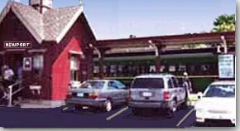
Figure 1 Newport Depot
All trains leave from the Train Depot at 19 America's Cup Avenue in Newport. This is just North of the Marriot Hotel, across from the Newport County Convention and Visitors Bureau. Train rides are a scenic 80-minute, nine-mile round trip along the East shore of the Narragansett Bay.
The train travels through the Naval Base and passes Pier One, the location of the three large naval warships. Passengers see Narragansett Bay dotted with various sailing and power craft from our scenic train.
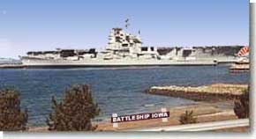
Figure 2 Battleship Iowa
Newport has a special sunset over the Bay, bringing enjoyment to all passengers. The view towards Jamestown and Quonset Point area is superb. Numerous power and sail craft, tugs with barges, and tankers bringing petroleum products to New England, flourish in our view of the beautiful bay. The scenery on the Old Colony & Newport Railway has been enhanced with the addition of two mothballed carriers and a battleship that were relocated from the closed Philadelphia Navy Yard. The aircraft carriers Forrestal and Saratoga, along with the Battleship Iowa, are now on display at Pier One.

The Ride
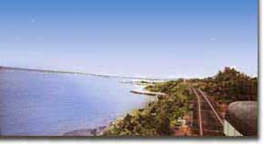
Figure 3 Heading North

The passengers sit back, relax, and enjoy the salt air breeze as they travel along the cozy west shore of Aquidneck Island (Newport RI) in an open platform coach built 1904 or 1884 parlor car.
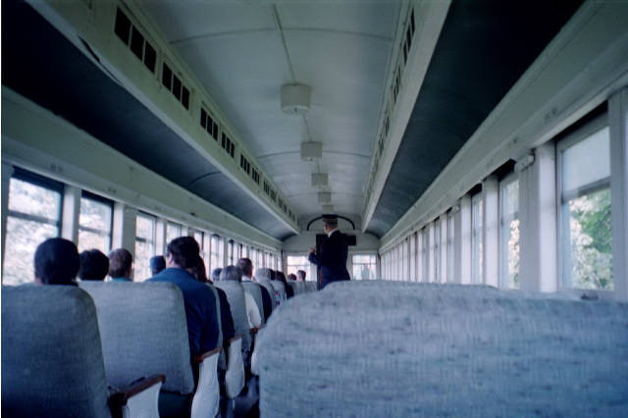
Figure 4 The Coach
Coach passengers enjoy a ride in a vintage car with a 'turn of the century' atmosphere seating in one of 72 seats heated by a potbelly stove.
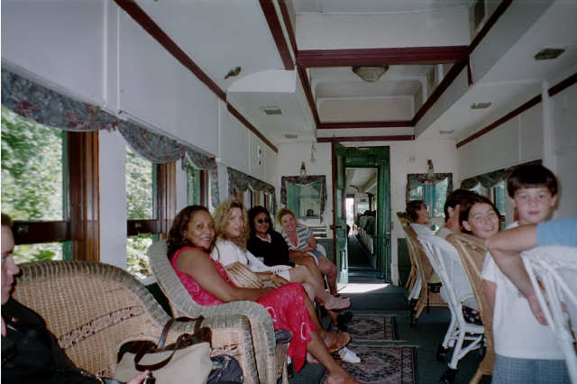
Figure 5 The Parlor Car
First Class passengers will enjoy the '1884' sumptuous private parlor car with individual wicker chairs, limited to 30 and all facing the Bay. The parlor car also enjoys the presence of a full retention toilet system installed in 1992, a potbelly stove, a private office and a food preparation area.
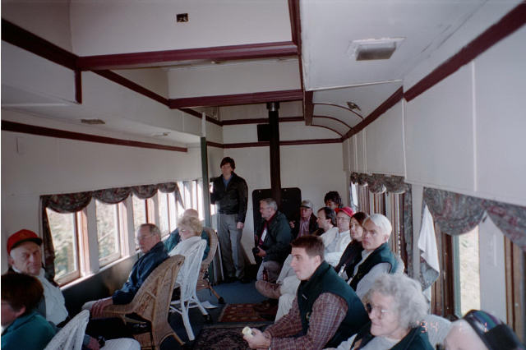
Figure 6 The Parlor Car & Stove
Our passengers experience a once forgotten era as they travel through the noted Newport RI Naval Base and along scenic Narragansett Bay with its scenic vistas of ships sailing in the bay, natural rocky beaches and wildlife that have adjoined the railway since 1864.

The History of the Newport Line
In an age mercifully innocent of environmental impact studies, suburban shopping plazas, and the universal motorcar, the only thinkable means of overland transit was via the Old Colony Railway that linked Boston with distant points in southeastern Massachusetts and Rhode Island. This legendary carrier was one of the best managed of all Railways and a veritable bonanza for its stockholders. For sixty-seven years it grew and prospered until 1893, when the expanding New York, New Haven & Hartford Railway leased the Old Colony for a period of ninety-nine years. Although notable improvements and increased service were introduced by the New Haven management, the personalized service of the Old Colony was lost. The zenith of passenger service to and from Newport was reached in 1913.
Newport County was no exception to the Railway fever that was sweeping the country during the middle years of the nineteenth century. The Old Colony Railway terminated in Fall River in 1854, and that city was taken with its importance as a commercial center. Aquidneck Islanders (Newport) desired to be part of the growing national rail system. At the time, Newport was well served by coastal steamboats.
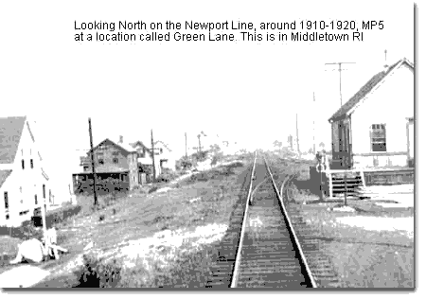
Figure 7 Green Lane
The Old Colony had little interest or inclination to buy an expensive right-of-way from the Massachusetts state line to Newport. Involved residents of Newport County agreed among themselves to offer the Old Colony Railway a 50 foot wide right-of-way from the Massachusetts state line to Newport if the carrier would construct a southerly extension. This action had the desired effect, as the property offered was prime and located almost entirely along the level shore of Narragansett Bay. It would be scenic as well as useful. On April 9, 1861, the Old Colony was authorized to build and operate a Railway from the end of track in Fall River, to the Rhode Island state line, to connect with a Railway to be built from Newport in a northerly direction.
In 1862, The Fall River line was extended toward Newport under the corporate title of Newport and Fall River Railway. This line was merged into the Old Colony and Fall River Railway, which was then, renamed the Old Colony & Newport Railway. The citizens of Fall River felt dismay and chagrin over the prospect of becoming patrons of a way station. Construction proceeded according to schedule with the exception of the bridge across the Sakonnet River. Initial attempts at overcoming this major obstacle met with failure due to tidal currents; however, substitution of stone for dirt fill solved the problem. A passenger train was run to Stone Bridge Village, Tiverton, on November 19, 1863. Regularly scheduled through service commenced on February 1, 1864.
An 1888 map showing the extensive Old Colony system throughout the southeastern Massachusetts and Rhode Island. Distant points to the north were Lowell, and to the west Fitchburg.
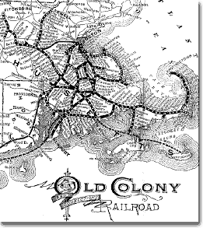
Figure 8 Old Colony Map
With the establishment of direct rail service to Boston, Newport enjoyed further prestige with the announcement that Fall River Line steamships would terminate at Long Wharf, Newport. The famous 'Boat Train' would now speed on to Newport after only a brief pause at Fall River. This arrangement remained in effect for five years until 1869.
The Old Colony & Newport timetable dated November 12, 1866 reveals that the carded time for the 'Boat Train' between Newport and Boston was two hours and fifteen minutes with stops at Fall River and Taunton. The Old Colony & Newport established stations at Portsmouth Grove, Bristol Ferry, and Tiverton. At the time Aquidneck Island's economy was agricultural and Middletown and Portsmouth were sparsely settled.
As time when on, the Railway sponsored excursions, at very low rates, to attract tourist patronage. A Sunday round-trip from Boston to Newport for a dollar was immensely popular. Another feature designed to attract business was a Railway sponsored summer development at 'The Hummocks' in Portsmouth. Land was available at bargain process for seasonal rentals and many Fall River residents took advantage of the offer. They also bought commuter tickets to get to their jobs in the city. Eventually the tenants bought the land from the Railway and became permanently established.
At the turn of the century, regular stations with resident agents were located at Middletown, Melville (Portsmouth Grove), Portsmouth, Bristol Ferry and Tiverton. Flag stops were made at Aquidneck, Cory's Lane and The Hummocks. Portsmouth station also served the adjacent coalmines but coal never became an important factor in freight revenue. 'Island Coal' had an infamous reputation for being slow to ignite but once burning, so hot that it would ruin a normal firebox. It was useless for locomotives or steamships.
For many years the Newport Line was served by a handsome express train known unofficially as 'The Dandy Express'. Its consist included a Pullman parlor car to care for first class clientele who insisted on privacy and comfort. 'The Dandy' was a morning train from Newport to Boston with a late-afternoon departure from the 'Hub'. The travel time was under two hours.
Regularly scheduled passenger service reached an all-time high during the summers of 1912 and 1913 when 24 trains a day arrived and departed Newport between 5:55AM and 11:03PM. Added to this impressive total were two scheduled freight trains a day, extra excursion specials and frequent private charter used by summer colonists who owned 'cottages' in the environs of Bellevue Avenue and the Ocean Drive.
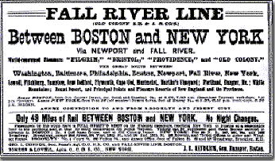
Figure 9 Fall River Line Poster
Several yard tracks were reserved for private cars. On occasion the eastbound Fall River Line steamer would be hours late due to storm or fog conditions. The Railway would make up a special extra to speed passengers to Boston. As many cars as needed would be waiting at Newport's 'Wharf Station' with a pair of ten-wheelers hot and ready displaying white flags.
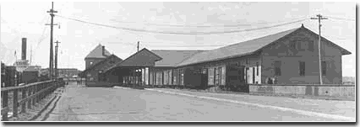
Figure 10 Newport Wharf Depot
The Newport Wharf Depot was pictured as this in 1919. Seven years previous 24 trains used it daily.
After World War I, the frequency of service went into a decline that was never reversed. The only notable change took place in the summer of 1929, when a weekend sleeper bound for Newport left Grand Central Terminal, New York, attached to an overnight New Bedford train called 'The Harpooner'. It returned to New York on Sunday night.
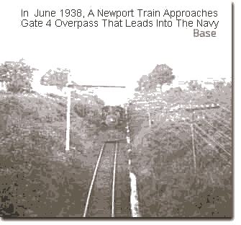
Figure 11 Gate 4 Overpass
The early 1930's, the private automobile and expanding bus service was cutting deeply into the New Haven's branch line revenues. Patronage on the Fall River Line ships was poor during the fall and winter months. By Mid-1937, the great steamers were gone and one train a day was serving Newport. Early in 1938, the Railway Mail Service contract to Newport was terminated and the last passenger train to Boston left without fanfare. With the exception of military extras during World War II, the one week during 1954 when the New Haven operated shoppers' specials to Fall River while Stone Bridge was closed to auto traffic, through passenger trains from Newport joined the steamers and trolleys on the more orderly past.
Rail freight service to Newport was continued on a daily basis. The old passenger station located between Marsh Street and Long Wharf was razed in 1939 and replaced by a large rectangular freight house. The combination Railway and steamer terminal at the end of Long Wharf was used for any years by the US Navy. Shortly after the Navy abandoned the facility, the former terminal was burned by vandals.
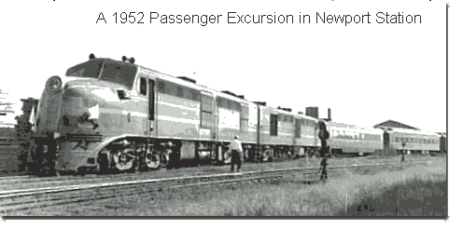
Figure 12 Excursion
During the 1960's the impact of the Interstate Highway System was felt by Newport's rail freight service. Daily service was reduced to tri-weekly and then once a week. In 1968 the New Haven Railway was bankrupt, and as such, was ordered taken over by the new giant Penn Central System. Two years later Penn Central was in the hands of receivers thanks in part to having the former New Haven. Penn Central service to Newport was replaced by the Consolidated Railway Corporation. Conrail, however, was merely designated operator of the Newport Branch on most of Aquidneck Island. Penn Central had filed for abandonment and with those plans imminent, the state of Rhode Island bought the line from the 'estate'. Title passed on the southerly 18.6 miles.

Membership

Supporting Members
You can be a supporting member through your tax-deductible contribution. Join today and save a part of history. Memberships are: Individual $25, Family $35, and Life $200 which entitles members to participate in all activities of the foundation, ride free and attend all meetings

Working Members
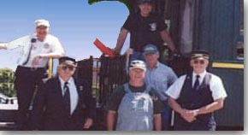
Figure 13 Volunteers Enjoying a Weekend
The Old Colony & Newport Scenic Railway is interested in members who wish to join this educational foundation as an operating member, by learning how to operate and work around large Railway equipment. There are many volunteer members, who work on the Railway enjoy the privileges above but without any membership dues. Most people ask if they have to be here every weekend. The answer is No! Whatever time that they have available can be worked into our training and schedule.
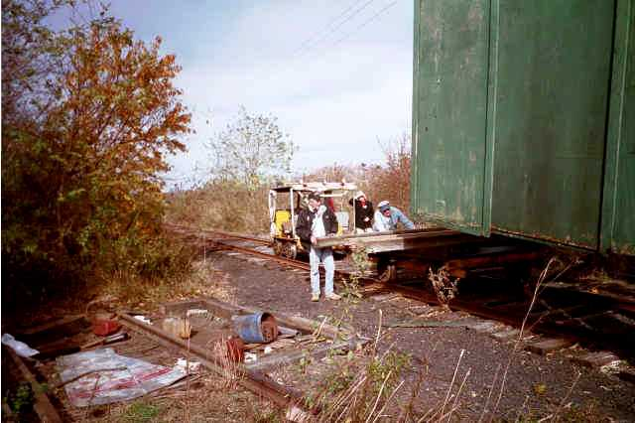
Figure 14 Volunteers Moving the Track Car Shed
If you have the desire to work on and/or operate Railway equipment, then The Old Colony has the training program to help you master that job and function as a working volunteer. Most of the people working at the Old Colony have other occupations that they work at such as Teachers, Technicians, UPS Drivers, Accountants, Lawyers, Students, Electronic Workers, etc. Some of our members have gone on to other Railway activities, such as: Amtrak Engineer, Guilford Engineer, New England Central RR Manager, New England Central Railway Engineer, and Hobo/Winn RR Engineer, Naugutuck RR Engineer. Most had no or little experience when they started. They developed proficiency in Railway safety by learning from the many experienced members.

The Newport Dinner Train
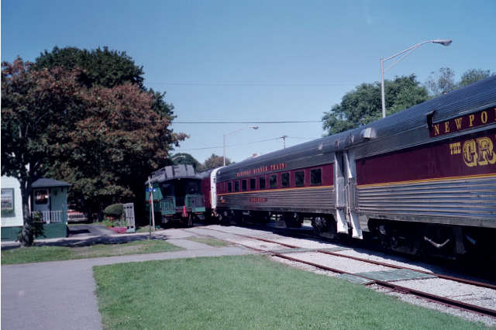
The Newport Dinner Train is separately owned and operated. It leaves from the same depot. It enjoys the same great scenery with the addition of a unique fine dining experience.

Photo Gallery

The following photos appear on the OCNRR website.
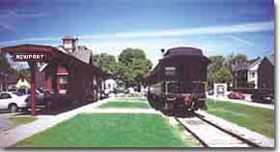
Figure 15 At the Newport Depot
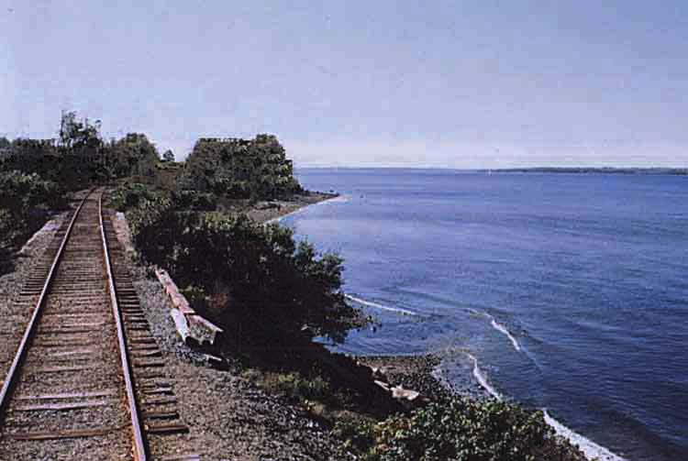
Figure 16 Heading South at Lawton's Valley
Figure 17 Heading North at McAllister's Point
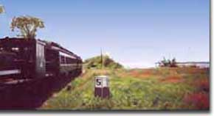
Figure 18 Mile Post
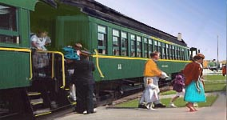
Figure 19 Disembarking at the Station

The following photos appear on the other websites.
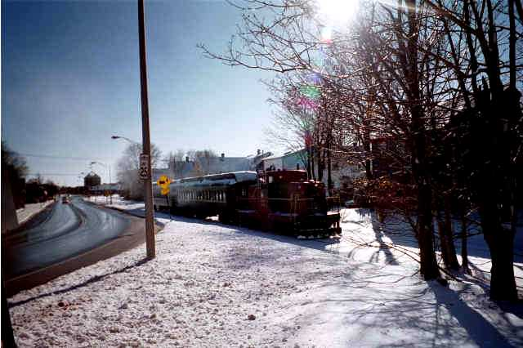
Figure 20 Leaving Newport on a Snowy Day
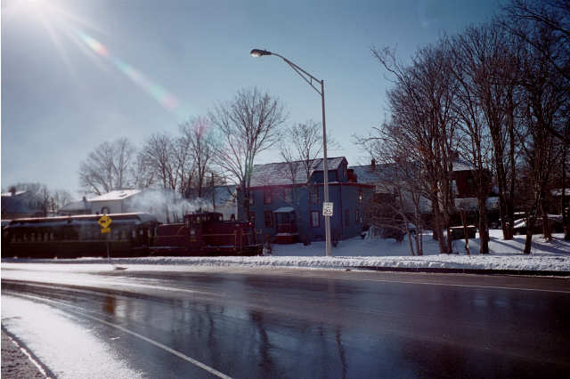
Figure 21 Old Colony Passing Stacy House

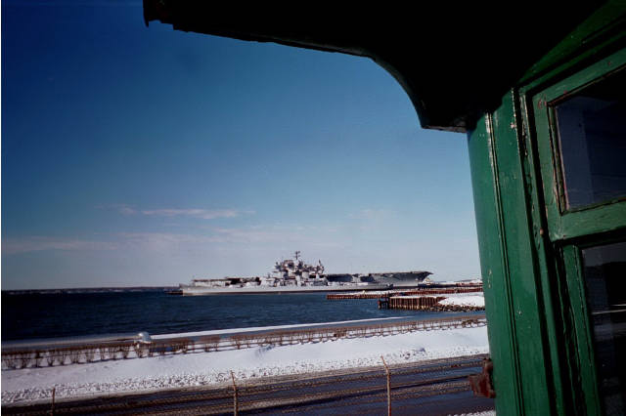
Figure 22 Battleship Iowa
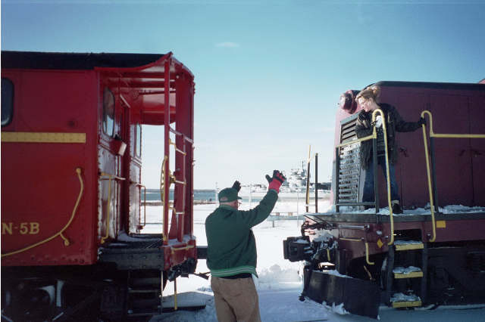
Figure 23 Coupling in the Snow
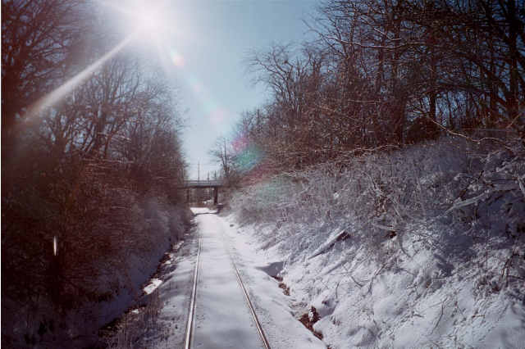
Figure 24 Track at Gate 4
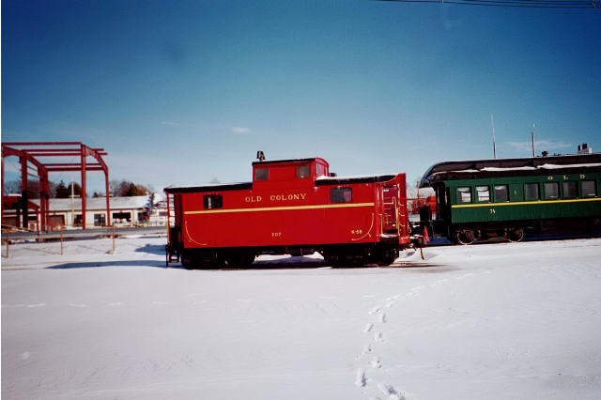
Figure 25 Caboose in the Snow
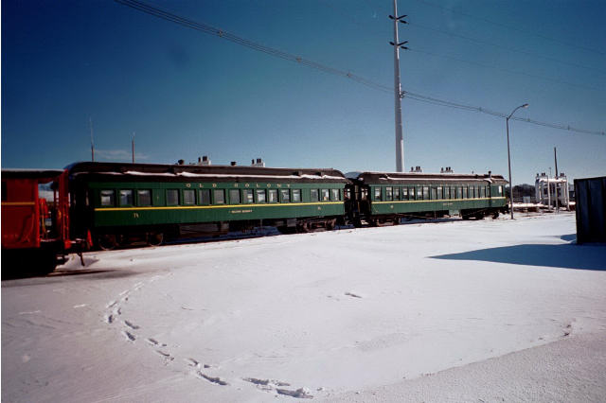
Figure 26 Passing on a SnowyDay
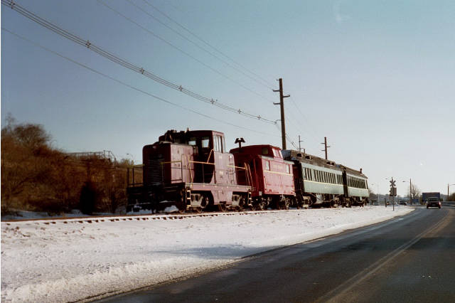
Figure 27 Burma Road

Figure 28 Better Weather is Coming
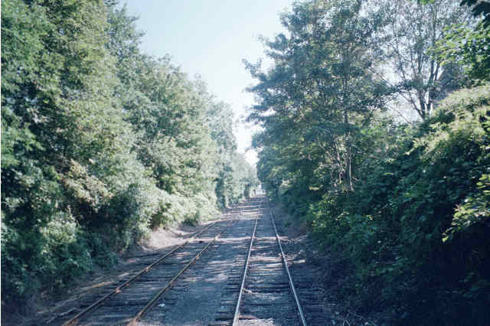
Figure 29 Downtown Newport Tracks
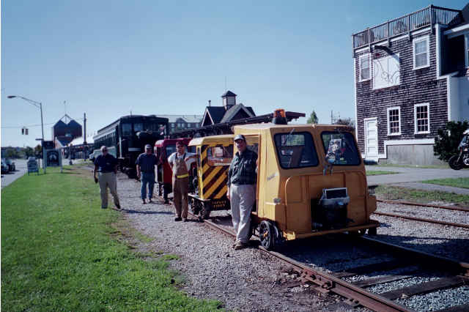
Figure 30 Track Cars Come to Town
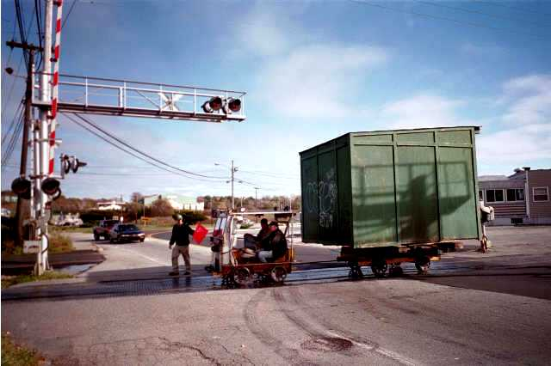
Figure 31 Heading to Melville with the Shed

Credits
- The information in this document was gathered, in the most part, from the Old Colony Newport website. The address of this site is http://www.ocnrr.com. The website was built and is maintained by George Kenson.
- The History of the Old Colony & Newport Railway was written by Donald O'Hanley, author of 'Newport - by Trolley!' which was published in 1976.
- Photos were taken by George Kenson, Donald Donovan and Peter Martin. Historical information was provided by Donald O'Hanley and George Kenson.
- Additional photos of the Old Colony & Newport Railway can be seen at the following websites:
http://stacyhouse.home.mindspring.com
http://photos.nerail.com

Contact Information
The Old Colony & Newport Railway can be reached at the following:

Telephone:
(401) 849-0546

Mail:
Post Office Box,
Newport, RI O2840

Email:

Donihawk@aol.com

Web site:
www.ocnrr.com

Publication Credits
This document was compiled by Peter Martin and Louise Casavant for the Old Colony & Newport Railway from materials of the Old Colony & Newport Railway and others.
This brochure was published by:
Peter Martin
Stacy House Designs

Addition copies available at cost.

Telephone:
(401) 847-0651

Web site:
www.stacyhouse.com

